1. Topology

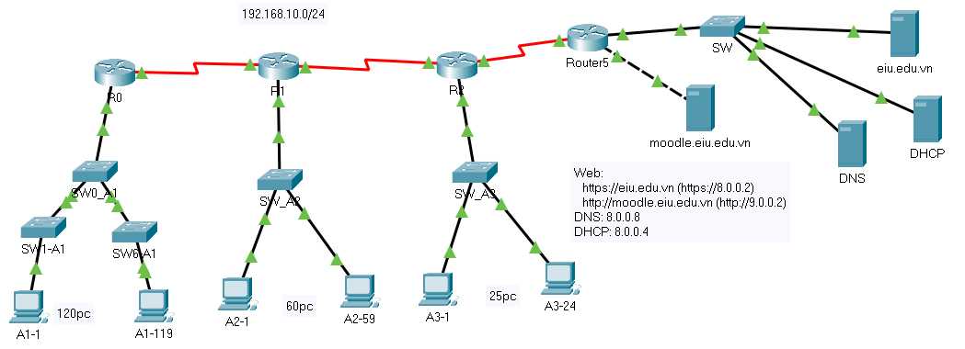

**I. Network configuration**

**1. From the file Assignment 5.pka, complete the diagram as shown above.**

**2. Configure the websites for moodle.eiu.edu.vn and eiu.edu.vn:**

* Use the HTTP protocol for the website moodle.eiu.edu.vn

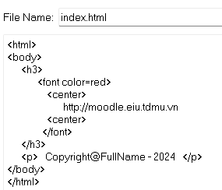

* Use the HTTPS protocol for the website eiu.edu.vn

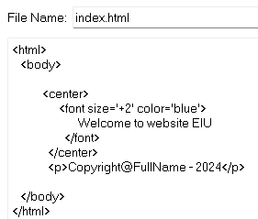

**3. Access the websites eiu and moodle from the PCs (A3-1 and A1-1) :**

***Access via the server's IP:***



* + A3-1: ?

* + A1-1: ? Success

Success or not?

***Access via the domain name: ( tên miền , ip phải là duy nhất mới dung được )***

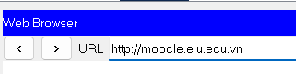

* + A1-1: ?

Success or not? Why?

**Đặt địa chỉ IP cho eiu.edu.vn ( đặt địa chỉ ip và default gateway )**

**4. Configure the DNS service on the DNS server to resolve the domains for moodle.eiu.edu.vn and eiu.edu.vn**

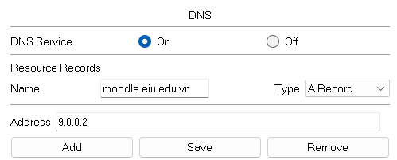

***Access the websites eiu and moodle from PC A1-1 using the domain names:***



* + Result: ???
  + Set the DNS address on A1-1 to 8.0.0.8
* A screenshot of a computer

  Description automatically generated
  + Access again:
* A screenshot of a computer

  Description automatically generated
* A blue and white box with red text

  Description automatically generated

**5. Configure the DHCP service on the DHCP server to assign dynamic IPs to A1:**

**Nhấn add**

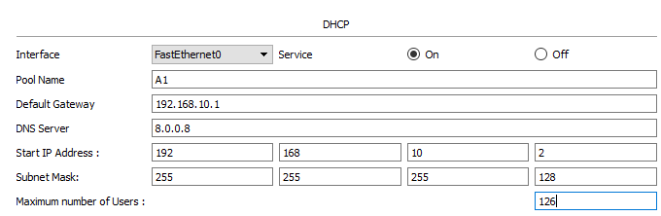

* + Switch PC A1-1 to obtain a dynamic IP and check: A screenshot of a computer

    Description automatically generated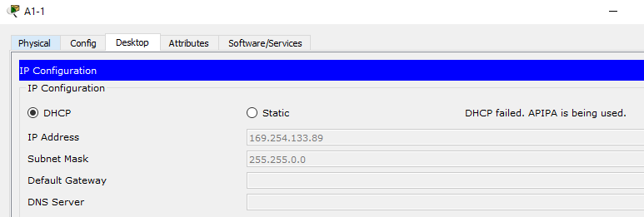

* + Configure the IP helper-address command on R0, go to interface g0/1 (the interface to the A1 network on the router) and enter the command ip helper-address 8.0.0.4:

Kéo cáp Console ra PC0 :

Vô PCO 🡪 Terminal 🡪 setup cho R0

Xong vào PC A1-119 Chỉnh sang DHCP địa chỉ sẽ đẹp : 192.168.10.3 255.255.255.128

R0(config)#int g0/1

R0(config-if)#ip helper-address 8.0.0.4

* + Check the result of the IP assignment on PC A1-1

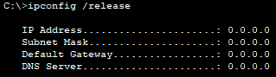

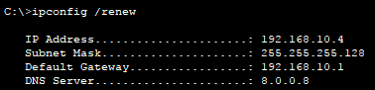

ARB : không bao giờ ra khỏi mạng LAN

**6. Explain the operation of the 3 layers (application, presentation, session)**

**7. Explain the operation mechanism of application layer protocols: HTTP, HTTPS, DNS, FTP, DHCP, SMTP**

**II. IP calculation**



Divide the address 192.168.STT.0/24 into subnets to assign IP addresses for the networks according to the following diagram (STT is number order in class list)

Lấy 1 bit làm network

|  |  |  |  |  |  |  |
| --- | --- | --- | --- | --- | --- | --- |
| **Lan** | **Hosts** | **Network** | **Subnet Mask** | **Start IP** | **End IP** | **Broadcast** |
| A1 | 120 | 192.168.12.0 | 255.255.255.0 | 192.168.12.1 | 192.168.12.1 |  |
| A2 | 60 |  |  |  |  |  |
| A3 | 25 |  |  |  |  |  |
| R0R1 | 2 |  |  |  |  |  |
| R1R2 | 2 |  |  |  |  |  |
| Reserve |  |  |  |  |  |  |

|  |  |
| --- | --- |
| *Questions* | *Answer* |
| 1. Identify the network id of the IP address of organization A1. |  |
| 2. What is the subnet mask of organization A1? |  |
| 3. Find the direct broadcast address of organization A1. |  |
| 4. Find total number of IP address possible in the network of organization A1. |  |
| 5. What is the first host IP address in the network of organization A1? |  |
| 6. What is the last host address of organization A1? |  |

|  |  |
| --- | --- |
| *Questions* | *Answer* |
| 1. Identify the network id of the IP address of organization A2. |  |
| 2. What is the subnet mask of organization A2? |  |
| 3. Find the direct broadcast address of organization A2. |  |
| 4. Find total number of IP address possible in the network of organization A2. |  |
| 5. What is the first host IP address in the network of organization A2? |  |
| 6. What is the last host address of organization A2? |  |

|  |  |
| --- | --- |
| *Questions* | *Answer* |
| 1. Identify the network id of the IP address of organization A3. |  |
| 2. What is the subnet mask of organization A3? |  |
| 3. Find the direct broadcast address of organization A3. |  |
| 4. Find total number of IP address possible in the network of organization A3. |  |
| 5. What is the first host IP address in the network of organization A3? |  |
| 6. What is the last host address of organization A3? |  |